Capstone Milestone Report
Chris Hamblin

Pilot Performance Calculators
A common problem in aviation is that there is no quantitative way to measure pilot proficiency. All pilots must meet minimum performance standards in order to receive their licenses and ratings. However, once these are acquired the only quantitative measure of pilot skill is their total accumulated hours, which has proven to be an unreliable measure. The recorded flight data will be analyzed to create a performance index that would allow pilots measure their performance and relative skill.
The Data Set
The data set consists of proprietary comma separated (.csv) data files that capture flight data during the approach to land phase of flight. The data includes multiple approaches into the San Francisco Airport (KSFO Runway 19L) by six different pilots. The data within the csv files includes sensor data needed to calculate pilot performance.
The approach to land is the most critical phase of flight. During the approach to land pilot performance is measured by three performance factors: 1) approach stability, 2) landing quality, and 3) landing precision. Approach stability describes the variance of movement along the X, Y, & Z axes. A stabilized approach is determined by pilots staying within given performance parameters. Independent variables include: airspeed, vertical speed, pitch rate, roll rate, and yaw rate. Landing quality is determined by the coordination of the landing and vertical acceleration of the aircraft. Landing precision is measured by the distance from the runway threshold and distance from the runway centerline.
The data recordings start at approximately 1000ft altitude and collect data through the landing and runway rollout. This restricts the data analysis to roughly the last 2-3 minutes of the approach. This limits the extent of the analysis that can be done but does keep the data files at a manageable size.
Some data cleaning will be needed to eliminate unnecessary variables within the data set. Data cleaning will also be needed to control for erroneous sensor values that may create statistical outliers or incorrect categorizations. Additional data wrangling will be needed to subset the time sequenced data at specific moments. For example, landing precision will be measured at the point of touchdown (i.e., when the landing gear contact the runway). Likewise, the approach phase will be subset to end at 50ft altitude.
Analysis
Analysis of the data will be conducted in a two-phase approach. The first phase the data will categorize the pilot performance of each approach. That is:
- Was the approach stable or unstable?
- Was the landing coordinated or uncoordinated?
- Was the landing smooth, rough, hard, or bounced?
- Was the landing precision optimal, acceptable, or out of bounds?

The second phase will conduct statistical analysis to determine what variables predict each of the three performance factors. This will most likely be a mixture of linear and logistic regressions.

The first phase has been successfully completed. Figure 1 below shows a data frame categorizing the stability of the approach. Figure 2 shows a data frame categorizing the landing quality. Figure 3 shows a data frame categorizing the precision of the landing and Figure 4 showing a plot illustrating the landing precision.

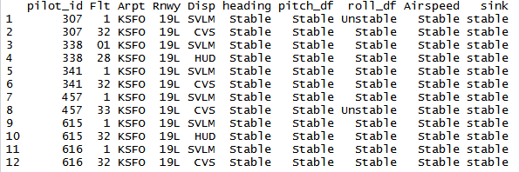
Figure 1. Data frame showing approach stability.

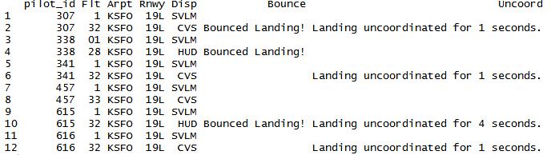
Figure 2. Data frame showing the categorization of the landing quality.

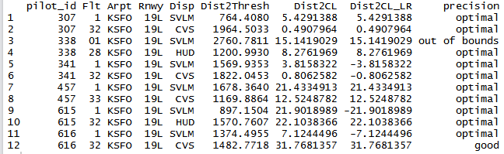
Figure 3. Data frame showing landing precision categorization.

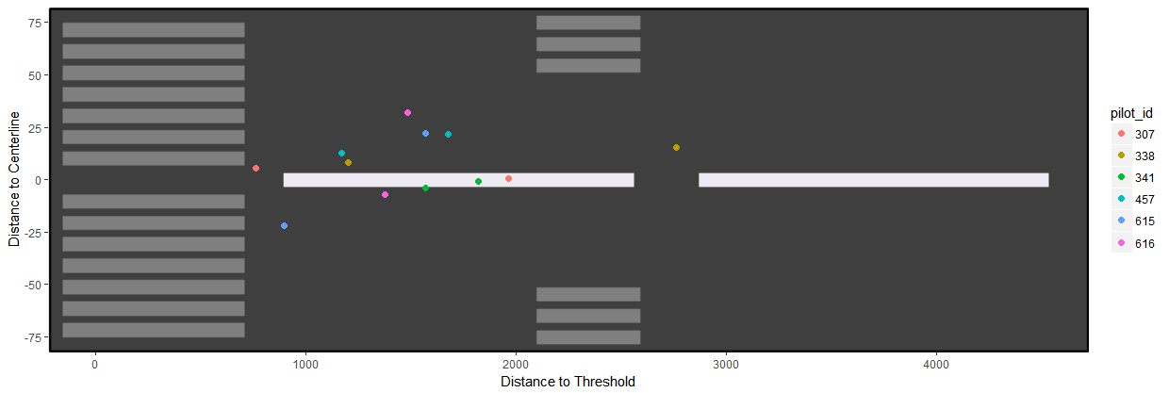
Figure 4. Landing Precision plot showing distance from centerline and distance from threshold.

